THE LOWELL SHARP INVITATIONAL ROUND 1 – BILL A

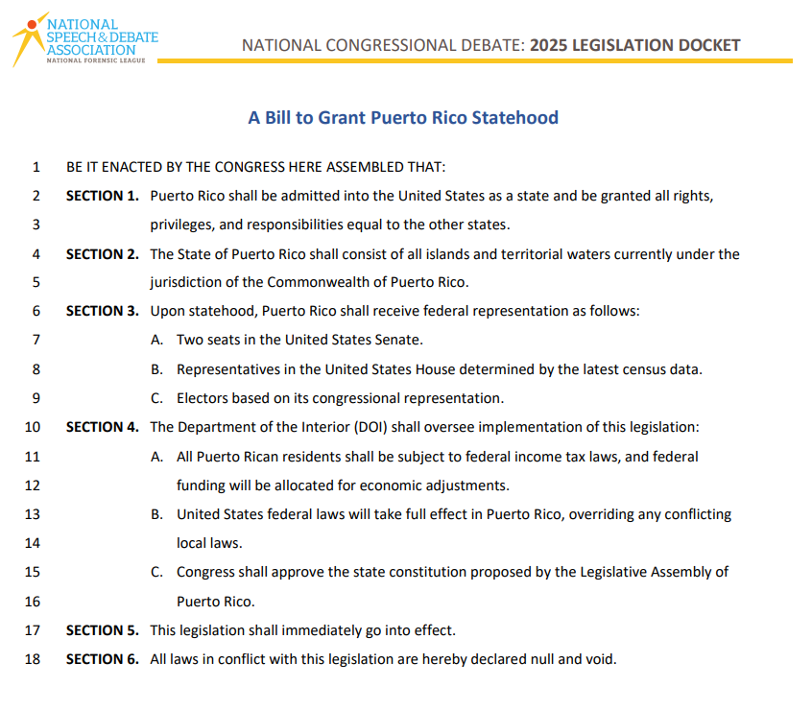

THE LOWELL SHARP INVITATIONAL ROUND 1 – BILL B

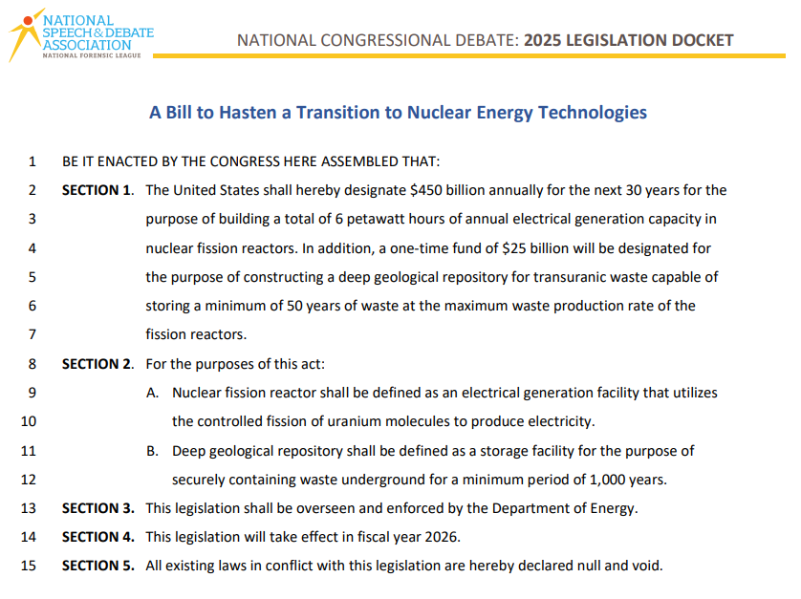

THE LOWELL SHARP INVITATIONAL ROUND 1 – BILL C

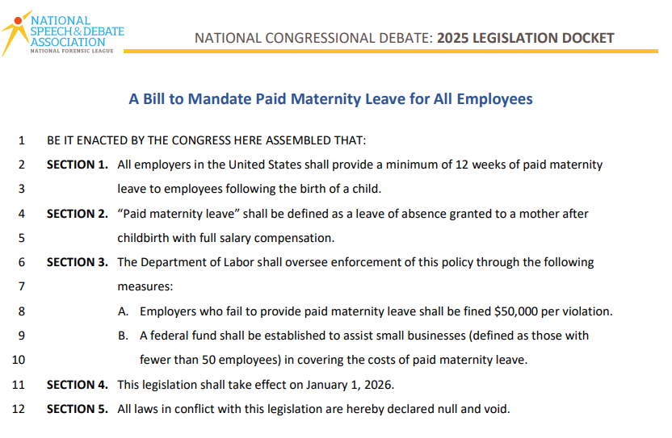

THE LOWELL SHARP INVITATIONAL ROUND 1 – BILL D
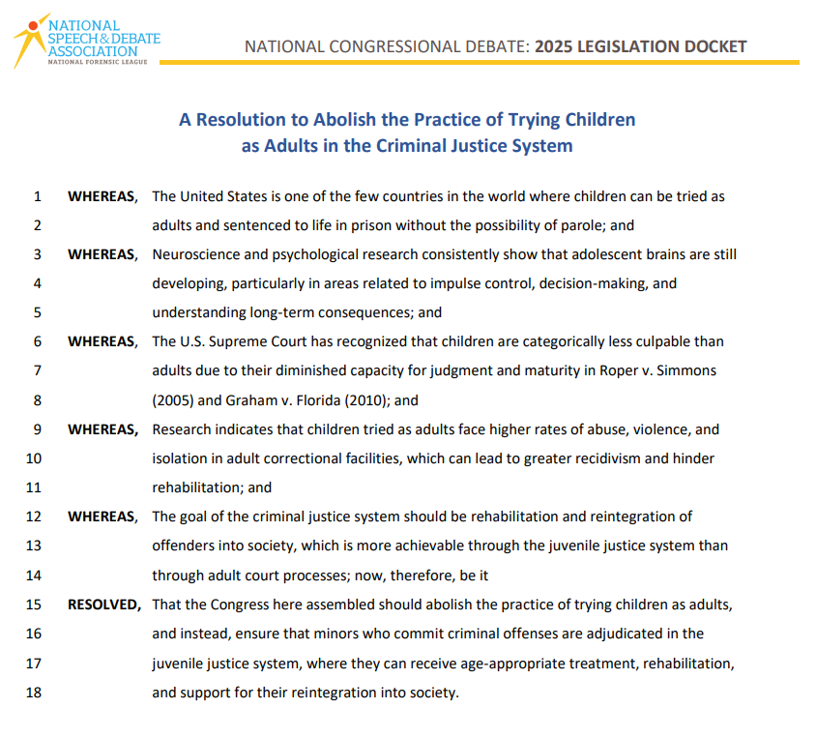

THE LOWELL SHARP INVITATIONAL ROUND 1 – BILL E

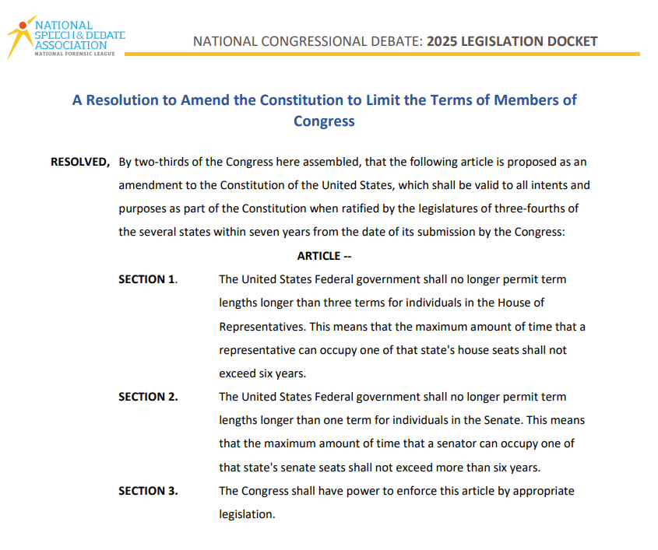

THE LOWELL SHARP INVITATIONAL ROUND 1 – BILL F

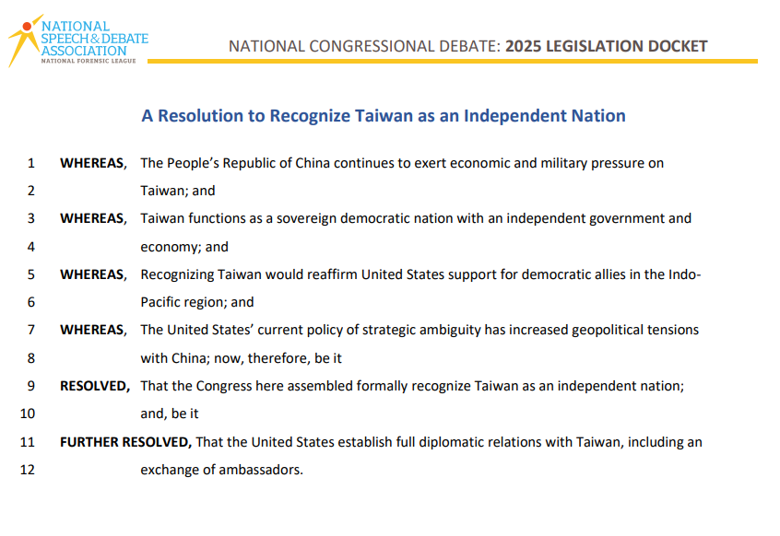

THE LOWELL SHARP INVITATIONAL ROUND 2 – BILL G

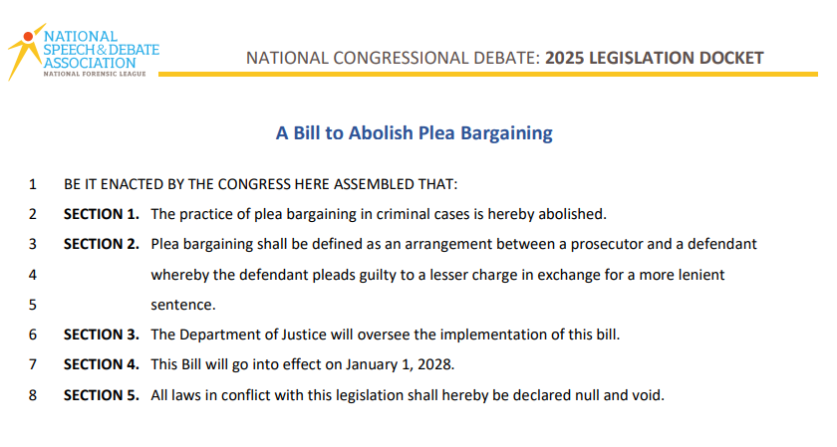

THE LOWELL SHARP INVITATIONAL ROUND 2 – BILL H

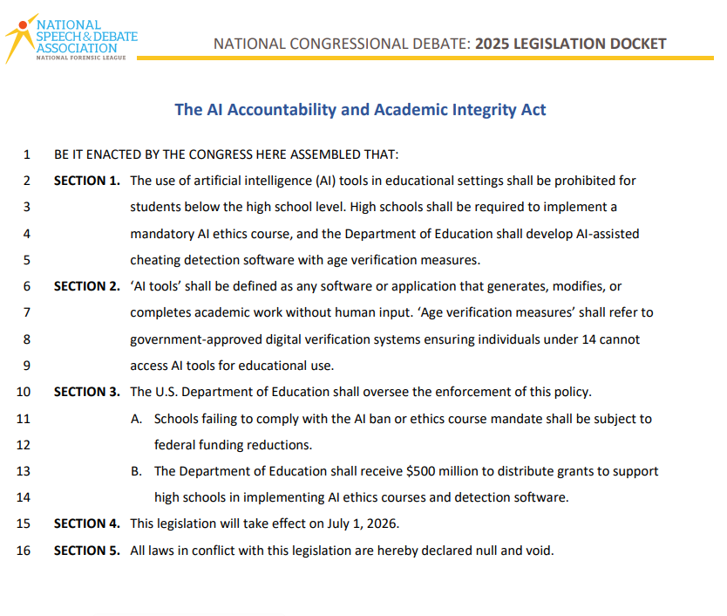

THE LOWELL SHARP INVITATIONAL ROUND 2 – BILL I

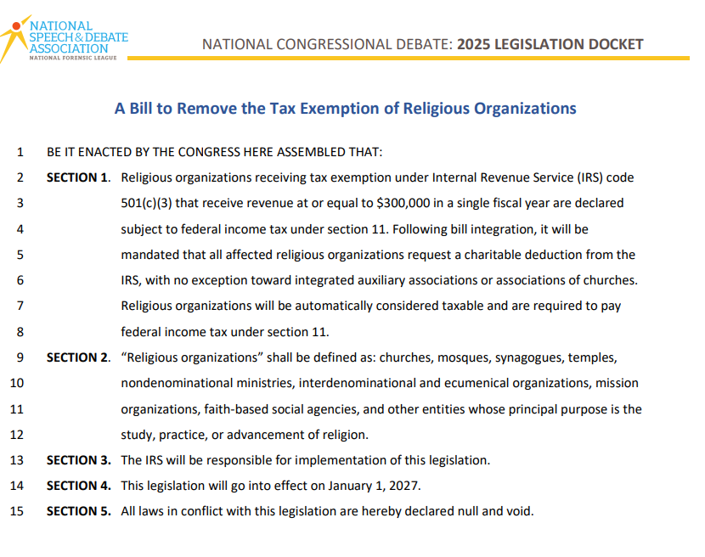

THE LOWELL SHARP INVITATIONAL ROUND 2 – BILL J

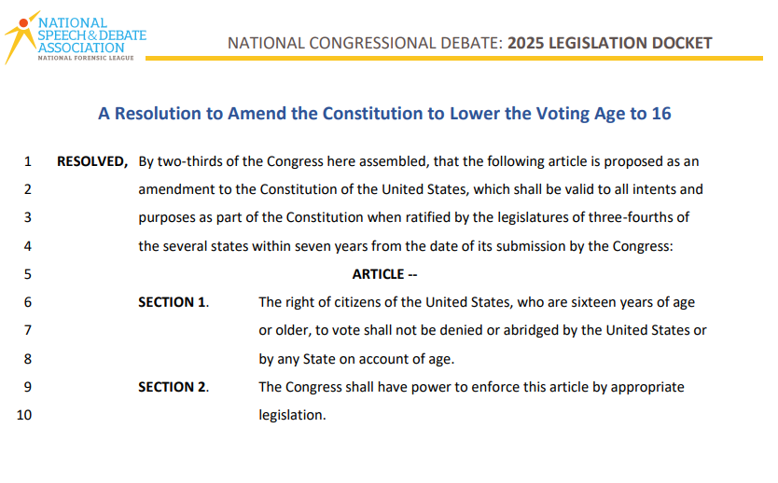

THE LOWELL SHARP INVITATIONAL ROUND 2 – BILL K

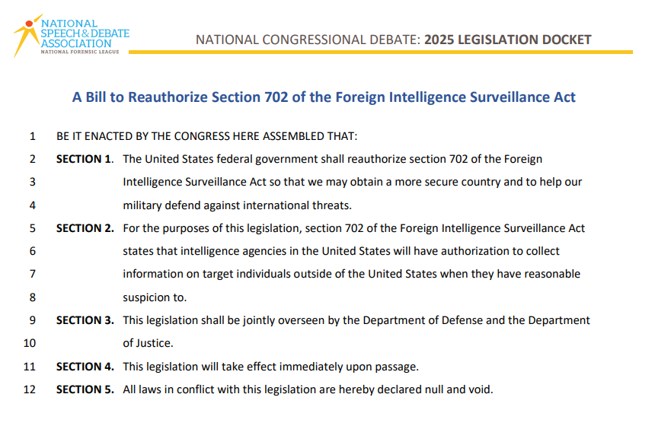

THE LOWELL SHARP INVITATIONAL ROUND 2 – BILL L

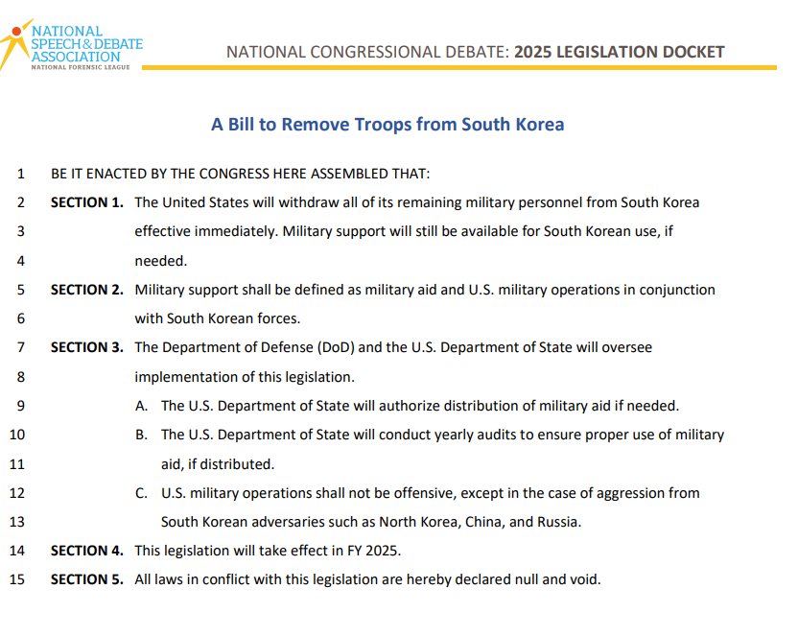

THE LOWELL SHARP INVITATIONAL FINALS – BILL M

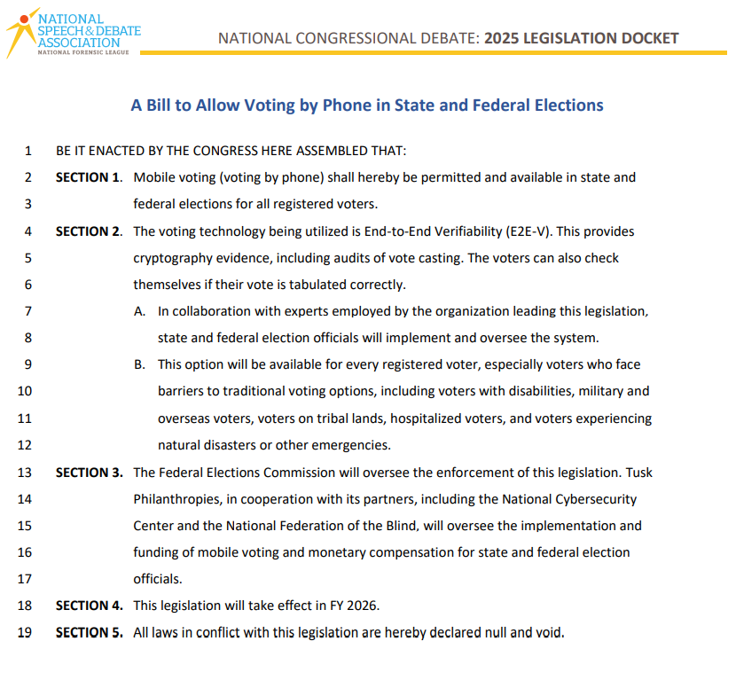

THE LOWELL SHARP INVITATIONAL FINALS – BILL N

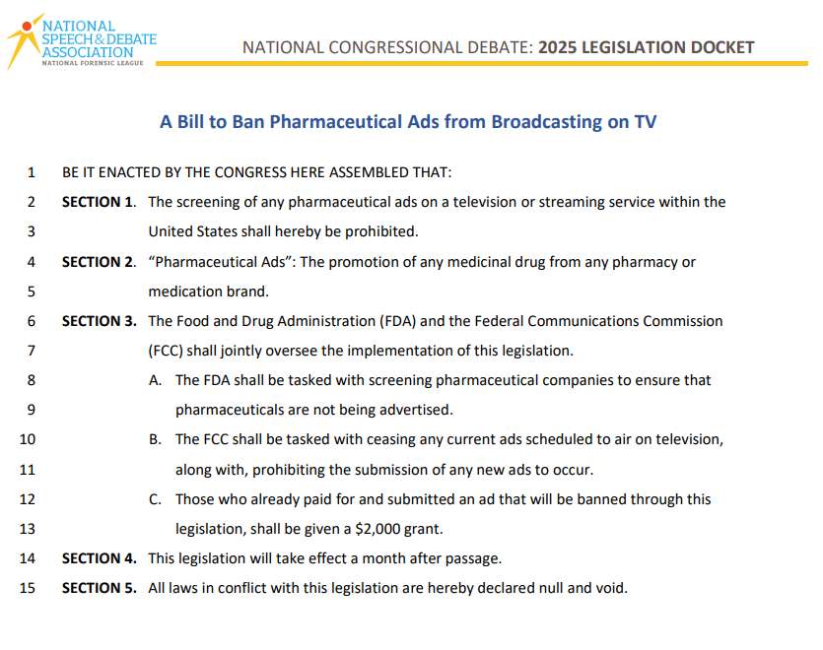

THE LOWELL SHARP INVITATIONAL FINALS – BILL O

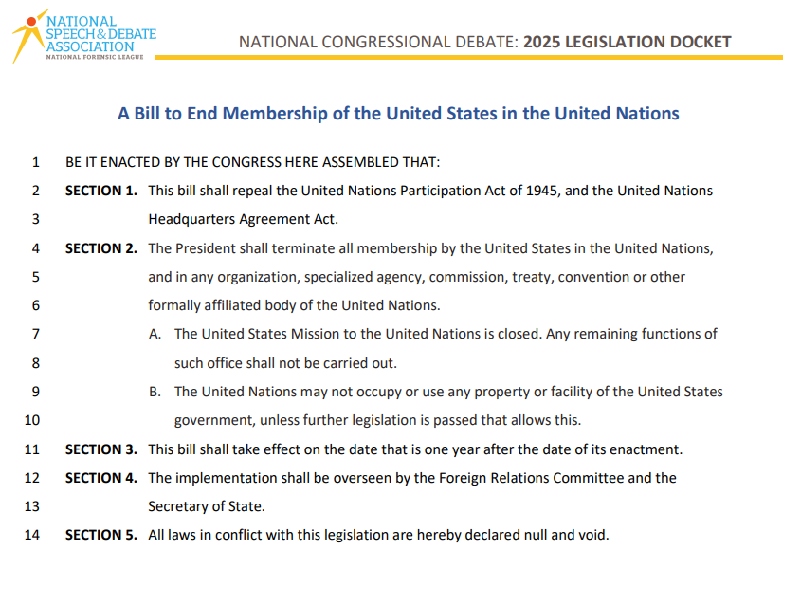

THE LOWELL SHARP INVITATIONAL FINALS – BILL P

